Pam Bean’s

2025 Montana Fair Housing Course

MFH’s mission is to promote and ensure non-discrimination
in Montana through outreach, education, dispute
resolution, and enforcement.
• Private, Non-Profit
• Serving residents across Montana
• Outreach and Education
• Dispute Resolution
• Investigation and Enforcement
• No Legal Counsel on Staff

“Fair housing” = making decisions about a household’s eligibility for services based on qualifications that don’t include reference to protected characteristics (classes).

Protected Classes - 1968
Race
- Physical traits common among peoples with shared ancestry
Color
- Skin Pigmentation
Religion
- Participating in or not participating in an organized religion
National Origin
- Country of an individual's birth or where their ancestors originated

Protected Classes - 1974
Sex
- Male or Female
- Sexual Harassment
- Domestic Violence Survivors
- Sexual Orientation and Gender Identity

Protected Classes - 1988
Familial Status
- Presence of children under the age of 18 in the household or pregnancy

Disability
- Denial of because of mental or physical disability
- Denial of Requests for Reasonable Modifications
- Denial of Requests for Reasonable Accommodations
- Design & Construction of Multi-family Housing

The Fair Housing Act
Section 804 [42 USC 3604]

Discrimination in sale or rental of housing
a) Refuse to sell, rent, negotiate, or make unavailable or deny
b) Discriminate in the terms, conditions, services or facilities
c) Make, print, or publish or cause to be made, a notice statement or ad indicating preference, limitation or discrimination (INCLUDES VERBAL STATEMENTS)
d) Indicating a dwelling is not available when it is available
e) For profit, to induce or attempt to induce a person to sell or rent a dwelling by representations that person/s are entering the neighborhood (BLOCKBUSTING)
f) Discriminate because of disability

Prohibitions, Continued
Sec. 805 [42 USC 3605] - Discrimination in Residential Real Estate-Related Transactions

Unlawful to make unavailable a residential real-estate transaction or in the terms or conditions of a transaction
Sales
Loans or Financial Assistance
Appraisals
Insurance
Inspections

Prohibitions, Continued
Sec. 806 [42 USC 3606] - Discrimination in Provision of Brokerage Services

Unlawful to deny any person access to, membership in or participation in any multiple-listing service, real estate brokers’ organization or other service, organization, or facility relating to the business of selling or renting dwellings, or discriminate in the terms or conditions of such access, membership, or participation.

Prohibitions, Continued
Sec. 818 [42 USC 3618] – Interference, coercion, or intimidation

Unlawful to coerce, intimidate, threaten, or interfere with any person in the exercise or enjoyment of, or on account of having exercised or enjoyed, or on account of having aided or encouraged any other person in the exercise or enjoyment of, any right granted or protected

This includes RETALIATION!

Steering - 24 CFR Part 14 - Implementation of the FHAA of 1988 - 100.70
Other prohibited sale and rental conduct
Steering practices, include, but are not limited to:

1. Discouraging any person from inspecting, purchasing or renting a dwelling because of . . .
2. Discouraging the purchase or rental of a dwelling because of . . . by exaggerating drawbacks or failing to inform any person of desirable features . . .
3. Communicating to any prospective purchaser that he or she would not be comfortable or compatible with existing residents of a community, neighborhood or development because of . . .
4. Assigning any person to a particular section of a community, neighborhood or development, or to a particular floor of a building, because of . . .

Redlining - 24 CFR Part 14 -
Implementation of the FHAA of 1988 Section 100.130
Discrimination in the terms and conditions for making available loans or other financial assistance.

In the decision to provide loans or other financial assistance, a lender may consider factors justified by business necessity, provided that such factors are unrelated to race, color, religion, national origin, sex, familial status or disability.

Blockbusting - 24 CFR Part 14 -
Implementation of the FHAA of 1988 Section 100.85 Blockbusting.

Consists of any effort, for profit, to induce or attempt to induce, a person to sell or rent a dwelling by representations regarding the entry into a neighborhood of a person or persons of a particular race, color, national origin, religion, sex, disability, or familial status.

Redlining - Creator: Home Owners' Loan Corp.
Government-sponsored corporation created in 1933 as part of the New Deal

August 15, 1938. Redlining of neighborhoods in the City/County of Denver. Minorities were excluded from home loan funds. They were considered poor economic risks.
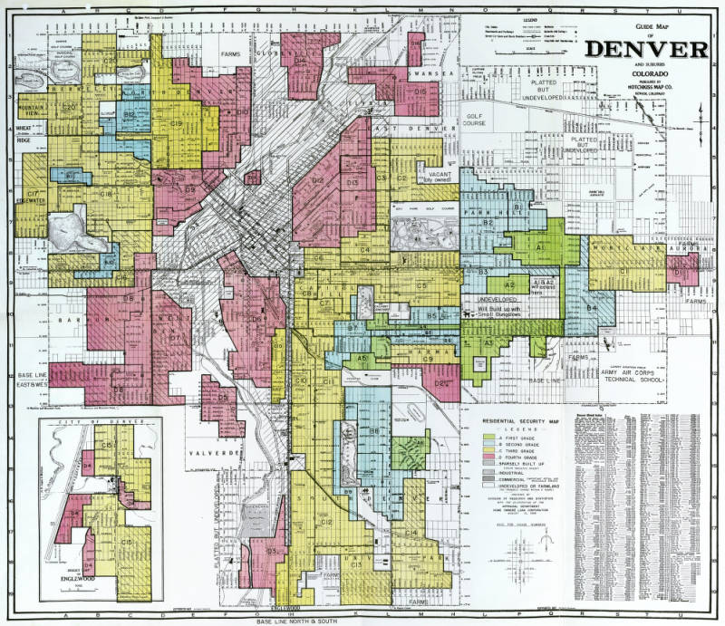

Advertising (CFR 109 and 110)
- Your brochures, business cards, social media, website, printed and radio materials, etc.
- Website accessibility compliance essential
- Include the 711 Relay for persons with disabilities
- Use the equal housing opportunity logo
- Post fair housing materials in your offices and common areas
- Avoid verbal statements inferring a limitation, preference or discrimination
- Your personal postings and statements
- Includes services following application and approval

MT Human Rights Act - 1974
- Race
- Color
- National Origin
- Religion
- Sex
- Disability
- Familial Status
AND
- Marital Status, Age, and Creed

1866 Civil Rights Act

Be it enacted . . . , “all persons born in the United States” (except for Indigenous
groups) were “hereby declared to be citizens of the United States” and that “such citizens of every race and color ... shall have the same right ... as is enjoyed by white citizens.”
NO EXEMPTIONS

1924 – Indian Citizenship Act – granted

Disability
- Section 504 of the Rehabilitation Act of 1973 – Federally Funded Programs
- Federal Fair Housing Act and MT Human Rights Act
- The Americans with Disabilities Act

DEFINITION: A physical or mental impairment that substantially limits one or more major life activities

Substantially Limits: Limitation is “significant" or "to a large degree.“
Major Life Activity: Activities of central importance to daily life.

Disability, Cont.
Who is Covered?
1) Individuals with a physical or mental impairment;
2) Individuals with a record of such an impairment; and
3) Individuals who are regarded as having an impairment.

Disability, Cont.
Who is not Covered?
1) Does not protect juvenile or sex offenders, by virtue of that status.
2) Does not protect persons who are currently using illegally controlled substances.
3) Does not protect an individual with a disability whose tenancy would constitute a "direct threat“ unless the threat can be eliminated or significantly reduced.

Disability, Cont.
- Denial of services because of having a mental or physical disability
- Denial of Requests for Reasonable Modifications
- Denial of Requests for Reasonable Accommodations
- Design & Construction of Covered Multi-family Housing

Disability, Cont.
Request for Modification:
- Physical alteration of a dwelling and/or public and common areas that will afford the person with the disability full use and enjoyment of the dwelling unit, including common use areas.
See: https://montanafairhousing.org/forms/HUD_DOJ_RM_joint_statement.pdf

Request for Accommodation:
- Alterations to rules, policies, practice or services to afford a person with a disability equal opportunity to use and enjoy the dwelling unit, including common use areas, by ameliorating the symptoms of the disability.
See: https://montanafairhousing.org/forms/HUD_DOJ_RA_joint_statement.pdf

Disability, Cont.
Requests can be made in any format, including verbal
- Use of specific language or forms can not be required
- Requests can be made on behalf of a person
- Visitors with disabilities may also submit requests –
- Residents responsible for compliance
- Can NOT require waiver of HIPPA protections

Housing Provider Has Right to Know:
What specifically is being requested;
- That the person requesting the accommodation or modification has a disability unless already known or visible (not diagnosis or treatment);
- The “nexus” between the request and disability-related need (unless obvious or known).

Information Received Must be Kept Confidential

Establishing the Nexus
- Major life activities limited by the disability that specifically relate to the request and need;
- Symptoms ameliorated to minimize the impact on major life activities;
- Provides an equal opportunity to use and enjoy the premises.

Denial of Requests
Requests can be denied if:
1. The person needing the request does not have a disability;
2. The person has a disability, but no disability-related need;
3. The request, if approved, would pose an undue financial or administrative burden;
4. The request, if approved, would pose a fundamental alteration to operations.

Both Parties . . .
Should engage in an:
INTERACTIVE DISCUSSION
to ensure clarity of requests, clarity of disability-related needs, options
available to meet the needs of the housing provider and the applicant/resident, etc.

Requests for Modifications
Can require household to:
1. Pay for modifications;
2. Deposit monies in interest bearing account for restoration of modifications that would interfere with the use of the unit by someone without a disability (not exterior modifications);
3. Purchase permits;
4. Have work done professionally.

- Section 504 requirements differ!
Can NOT require households to pay for mods and complete retros.

Let’s Try It:
New resident in a two-bedroom unit emails your office asking for you to:
- Widening of bathroom and bedroom door ways;
- Lowering of cabinets in kitchen and bathroom;
- Creating an accessible route from unit to on-site office;
- Remove carpet and install hardware flooring throughout the unit.

Requests for Accommodations
- Parking spot on the nearest accessible route
- Ceasing efforts to evict someone engaged in hoarding behaviors
- Moving a household to a ground floor unit
- Allowing a live-in aide (does not financially need to qualify)
- Allowing a household to end lease early without adverse action / fees
- Securing the services of a sign language interpreter
- Altering rent due dates without penalties
- Service and Assistance Animals
- Etc. . . .
Housing Provider can not assess fees, deposits, or additional
rent monies for accommodations

Let’s try it:
A resident verbally requests approval to:
1. Have a sign language interpreter for interactions with office staff; and
2. Have a live-in aide.

Service & Assistance Animals
A housing provider may refuse a reasonable accommodation for an animal if the specific animal poses a direct threat that cannot be eliminated or reduced.

- Beware of breed restrictions!
NOTE: Accommodations for insurance-related restrictions.

Service & Assistance Animals, Cont.
- Submission of certification of animal is not verification of disability and need;
- Verification of disability and need from an on-line source does not meet criteria unless medical treatment is provided virtually
- Ongoing relationship with healthcare provider exists
- Verification of disability-related need for each animal
- Secure approval before bringing animal/s to site
- HUD Service and Assistance Animal Memo
https://montanafairhousing.org/forms/2020HUDAsstAnimal.pdf

Service & Assistance Animals, Cont.
- Housing providers are encouraged to have an ANIMAL policy vs. a separate policy that applies to only service and/or assistance animals.
- Policies that are described as “PET” policies and then applied to animals necessary for a disability can cause confusion.
- No deposits, fees, or rent can be assessed for service and/or assistance animals.

Service Animals
Dogs or Miniature Horses, and, in Montana, also Service Animals in Training

Service Animals, Cont.
- Individually trained to do work / perform tasks
- Task(s) performed must be directly related to the disability
- No professional trainer or training certificate is required
- Emotional support, therapy, comfort, or companion animals are NOT service animals (no training involved)

To verify disability and need:
- Is the dog or horse a service animal required because of a disability?
- What work or task(s) is the animal trained to perform?

MCA 2023 - TITLE 49.

Human Rights Chapter 4. Rights Of Persons With Disabilities
49-4-203.
(1)"Housing accommodation" means any real property . . . that is . . . occupied or is intended. . . to be used or occupied as the home, residence, or sleeping place . . . does not include any single-family residence . . . furnish for compensation . . . one room . . .

(2)(2) "Service animal" means a dog or miniature horse individually trained to provide assistance . . . The term does not include an emotional support animal.

MCA 2023 - TITLE 49.

Human Rights Chapter 4. Rights Of Persons With Disabilities

49-4-221. Misrepresentation of a service animal.
(1) If a person knowingly . . represents that an animal is a trained service animal . . . to access the places . . . the person may be asked to remove the animal . . . and local law enforcement may be called to investigate.

49-4-222. Misrepresentation of a service animal – misdemeanor -- penalty.
(1) A person who misrepresents a service animal as provided in 49-4- 221 may be found guilty of a misdemeanor if . . .

Assistance Animals
- Bunny, Goat, Cat, Duck, Fish, Horse, Chicken, Hamster, Reptiles, Etc…

A Unique Type of Support Animal:
An individually trained capuchin monkey performs tasks for a person with paralysis. The monkey has been trained to retrieve a bottle of water from the refrigerator, unscrew the cap, insert a straw, and place the bottle in a holder.

The monkey is also trained to switch lights on and off and retrieve requested items. The individual has a disability-related need for this specific type of animal because the monkey can use its hands to perform manual tasks that a service dog cannot perform.

Unique Circumstances
Reasonable accommodations when the need involves unique circumstances ...
- The animal is individually trained to do work or perform tasks that cannot be performed by a dog.
Information from health care professional confirms that:
- Allergies prevent the person from using a dog; or
- Without the animal, the symptoms or effects of the person’s disability will be significantly increased;
- The individual seeks to keep the animal outdoors at a house with a fenced yard where the animal can be appropriately maintained.

MCA 70.24.114 Emotional Support Animals
Added to the Landlord & Tenant Act in 2023
(9) Nothing in this section may be construed to restrict existing federal law and state law . . .
2(b) if a tenant's disability-related . . . is not readily apparent, request supporting information that reasonably supports the tenant's need . . . Supporting information may include:
(i) information from a health care practitioner who has personal knowledge of the tenant's disability and is acting within the scope of the practitioner's practice . . . Information submitted under this subsection (2)(b)(i) must include the effective date, license number, and type of professional . . . ; and

(ii) information from any other source that the landlord determines to be reliable in accordance with the federal Fair Housing Act and Title 49, chapter 2; and

2(c) require proof of compliance with state and local licensure and vaccination requirements . . .
(3) . . . information for each emotional support animal must be provided pursuant to subsection(2).
(4) A landlord:
(a) may not request information . . . that discloses a diagnosis or severity of a tenant's disability or any medical records . . .
(b) shall issue a written determination . . .
(5) An emotional support animal registration of any kind, . . . is not, by itself, sufficient information . . .
(6) A tenant . . . is liable for any damage done to the premises or to another person on the premises by the tenant’s . . . animal.
(7) A health care practitioner may be subject to disciplinary action from the health care practitioner's licensing board for a violation . . .
(8) This section does not apply to a service animal as defined in 49- 4-203.

Design & Construction
- Covering buildings including 4 or more units.
- All ground floor units unless there is an elevator in the building, then all units reached by the elevator.

- Built for first occupancy after March 13, 1991, buildings should be designed and constructed in a manner that ensures –
I. public and common areas are accessible to and usable by someone in a wheelchair;
II. doors are designed to allow passage into and within all premises;

Design & Construction, Cont.
All premises contain:
I. accessible route into and through the dwelling;
II. light switches, electrical outlets, thermostats, other environmental controls in accessible locations;
III. reinforcements in bathroom walls to allow installation of grab bars;
IV. usable kitchens and bathrooms such that an individual in a wheelchair can maneuver.

Section 504 of the Rehabilitation Act of 1973
Provides protections only for persons with disabilities.

All federally funded programs and sites must comply.
Covered Entities Must:
• Identify 504 Coordinator and post contact information
• Cover costs for modifications and requires no retrofits
• Non-housing facilities must be accessible
• Requires program policies, rules, and forms be available in accessible formats
• 5% / 2% rule
• Deficiencies addressed in a 504 plan

Americans With Disabilities Act - 1990

Title I – Employment
- Employers with 15 or more employees
- MHRA does not require 15 or more
Title II – Public Services
- Federal & State Provided Services

Title III - Public Accommodations
- No individual shall be discriminated against in the use and enjoyment of goods, services, facilities, privileges, etc.
- Requires Website Accessibility

Title IV – Telecommunications (711 Relay Service)
Title V – Miscellaneous Provisions

Exemptions
Tribally Owned and Operated Housing – Can limit to tribal members.
Religious Organizations and Private Clubs - Can limit or give preference in the sale, rental or occupancy for other than a commercial purpose:
- To persons of same religion, unless membership is restricted based on race, color, or national origin.
- To club membership if club not open to the public, and as an incident to primary purpose/s provides lodgings

Multi-Family Units
- MHRA 49-2-305(11) – no more than two (age & familial status only)
- FHAA – 803(b)(2) – no more than four
- Owner must maintain and occupy one of living quarters as residence.
- Owner can not use an agent.

Exemptions - Single Family Homes
Sleeping Rooms - MHRA 49-2-305(2) Rental of sleeping rooms in single-family unit in which the owner resides provided the owner rents no more than three sleeping rooms.

FHAA 803(b)(1): single-family house sold or rented:
- owner does not own more than three;
- one sale in 24-months if owner isn’t most recent resident;
- no right to proceeds from sale or rental of more than three;
- no use of an agent;
- no publication, posting or mailing, advertising in violation of section 804(c)

Exemptions - HOPA
Exemption for familial status only.

62 & Older – 100% of residents in 100% of units

55 & Older – at least one person 55 or older in at least 80% of units
- Bi-annual survey verifying ages of residents
- Publishes and adheres to policies and procedures that demonstrate the intent

Filing a Complaint
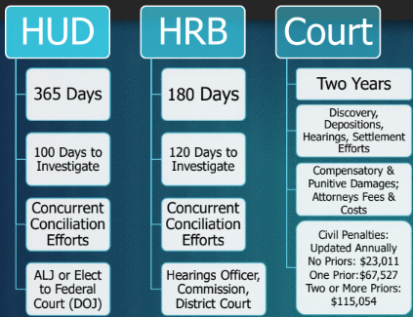

For More Information Contact:
Montana Fair Housing
(406) 782-2573 / (800) 929-2611 / MT Relay System: 711
Website: www.montanafairhousing.org

Dept. of Housing and Urban Development
1-800-877-7353
Website: https://www.hud.gov/program_offices/fair_housing_equal_opp

MT Human Rights Bureau
1-800-542-0807
Website: https://erd.dli.mt.gov/human-rights/

